ASSIGNMENT 1

CO1: Apply object-oriented programming principles and C++ constructs such as data types, operators and control structures to design and write structured OOP-based programs – the object-oriented paradigm and its basic principles, tokens, keywords, identifiers, constants, data types, type compatibility, variables, operators, implicit conversions, operator precedence and control structures.

Assignment Title: Design, Implement and Validate the Fare Logic of a City Metro Smart-Card System (Total Marks - 50)

Name : Vaishnavi S

Register number : 192521313
Nature of Assignment: Individual

Duration: 1 Week Submission Date: _6/11/26_
Bloom’s Levels Assessed: K5 – Evaluate (every task in this assignment is at K5 level) Mandatory Execution and GitHub Submission
- Every student must individually execute every task in this assignment, including all “Complete the Code” programs.
- Create a GitHub repository named DSA01-<RegisterNumber>-Assignment1 and share it with the course faculty (public, or private with the faculty added as a collaborator).
- Keep one folder for each task (for example: Task01, Task02 … or Q1, Q2 …), containing the C++ source files, input files and output screenshots.
- Include a README.md with your name, register number, compiler and version (for example g++ 13), the exact g++ command used to compile (for example g++ -std=c++17 -Wall -Wextra), the steps to run each program, and a short note of the result of each task.
- Commit your work progressively – at least one commit for each task. The commit history will be checked; a single upload of all files on the last day will not be accepted.
- Submit the GitHub link below and on the cover page of your report. An assignment submitted without a working GitHub link will not be evaluated.

GitHub Repository Link:
https://github.com/vaish63804/C--192521313--Vaishnavi.S

How to Answer the Additional Questions

Complete the Code: Copy the given code into your repository, replace every TODO with working code without changing the rest of the program, execute it and compare your output with the expected output.
Predict the Output: Write the exact output of the given program before running it. Then run it and explain every difference between your prediction and the actual output, using the C++ rules involved. Predictions written after running the program will not be credited.
Alternative Concept and Complexity Analysis: Describe how the solution would change if the alternative concept were used, with code or pseudocode, and analyse and compare the time complexity and space complexity of both solutions using Big-O notation, supported by your own measurements wherever possible.

Scenario — Namma Metro Smart-Card Fare System

A city metro rail divides its network into three zones – Inner, Middle and Outer. The fare is Rs 10, Rs 20 or Rs 30 according to the farthest zone travelled, with a 20% surcharge during peak hours (8–10 AM and 5–8 PM). Passengers use a stored-value smart card, and a journey is allowed only if at least Rs 50 remains on the card after the fare is deducted. Students and senior citizens receive a concession.
The first version of the gate software was written in a hurry. Some fares are off by a paisa, the peak check accepts 10 AM as peak and 8 PM as off-peak inconsistently, a negative balance once appeared on a card, and the fare values are typed in several places.
The number of journeys processed may grow:

1 station (20,000 journeys a day) → 1 line (500,000 a day) → whole network (3,000,000 a day)

You are required to analyse the problem, identify its objects, choose suitable C++ data types, constants, operators and control structures, implement the fare logic and validate it, so that every fare and balance is exact.
Design Challenge:

The metro is adding a fourth zone, a weekend discount and monthly passes.

Re-evaluate your original design and determine whether it should be retained, modified or redesigned.

TASK 1 – Understand the Problem and Identify the Objects 4 Marks Bloom’s Level: K5 – Evaluate
Analyse the fare problem from the object-oriented point of view. Discuss:
- The objects in the problem (card, passenger, journey, zone, fare table) and the data and behaviour of each
- How the same problem would be written in a procedural style, and what changes in an object-oriented style
- The basic principles of OOP – encapsulation, abstraction, inheritance and polymorphism – and where each could appear in this system
- The rules every correct journey must satisfy (for example: balance never below Rs 50 after a journey)

Code :

#include <iostream> using namespace std; class SmartCard { private:
long long balance; public:
SmartCard(long long amount) { balance = amount;
}

void displayBalance() {

cout << "Current Balance: Rs " << balance / 100.0 << endl;

}

void deductFare(long long fare) {

if (fare >= 0 && balance - fare >= 5000) { balance -= fare;
cout << "Journey Accepted" << endl;

} else {

cout << "Journey Denied: Minimum balance required is Rs 50"

<< endl;

}

}

};

int main() {

SmartCard card(10000);

card.displayBalance(); card.deductFare(2000); card.displayBalance(); return 0;
}

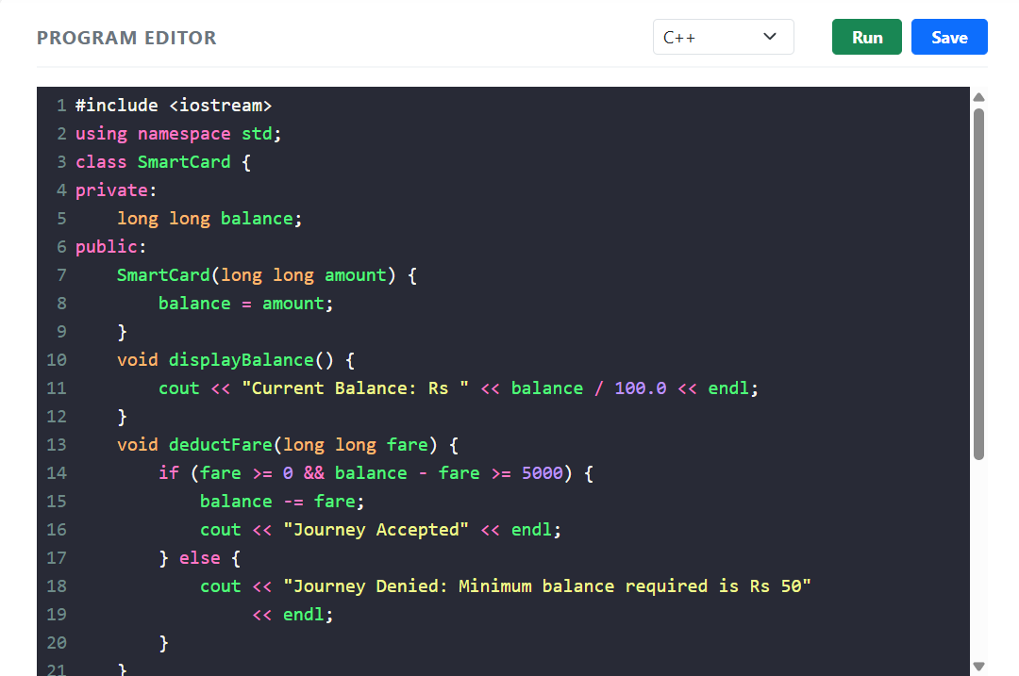

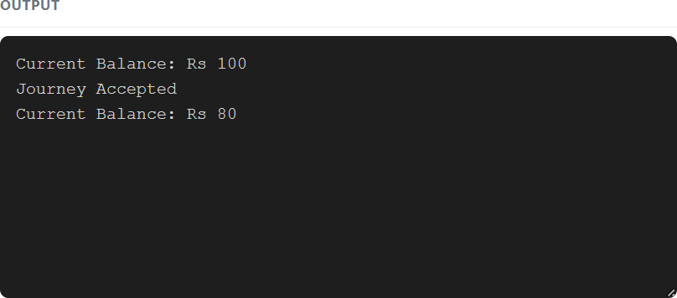

TASK 2 – Use Tokens, Keywords, Identifiers and Constants Correctly 3 Marks Bloom’s Level: K5 – Evaluate
Define the fares, surcharge and limits so that a revision is made in one place only. Discuss:

- The five kinds of tokens in your program (keywords, identifiers, constants, operators, punctuators) with examples
- #define, const and constexpr constants, and why constexpr is preferred for the fare table

- enum and enum class for zones, and why enum class is safer

- Naming rules and conventions for identifiers

Code:

#include <iostream> using namespace std;
constexpr int INNER_FARE = 1000; constexpr int MIDDLE_FARE = 2000; constexpr int OUTER_FARE = 3000;

enum class Zone { Inner,
Middle, Outer
};

int main() {

Zone z = Zone::Inner;

cout << "Inner Fare: " << INNER_FARE << " paise" << endl; cout << "Middle Fare: " << MIDDLE_FARE << " paise" << endl; cout << "Outer Fare: " << OUTER_FARE << " paise" << endl; cout << "Constants and enum class implemented successfully."
<< endl; return 0;
}

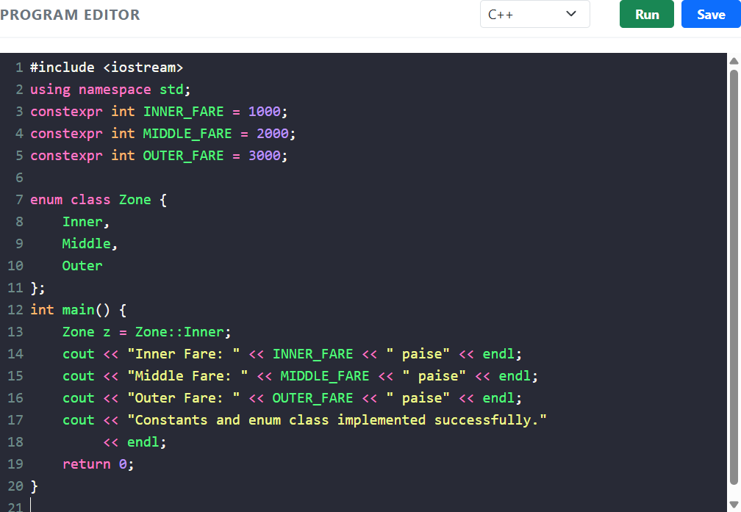

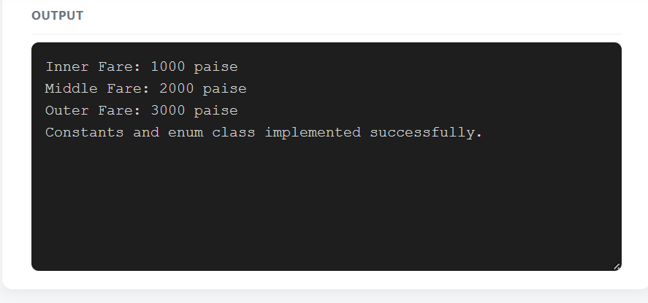

TASK 3 – Choose Data Types and Check Type Compatibility 4 Marks Bloom’s Level: K5 – Evaluate
Select a C++ data type for every value in the system. Discuss:

- The type chosen (bool, char, int, long long, unsigned, float, double, auto) for fares, balances, times, zone numbers and journey counts, with sizeof on your system
- Why money should be stored in integer paise and not as double rupees

- Type compatibility rules, and what the compiler does with int, double and bool values in the same expression
- The ranges from <climits> and whether int is enough for a day’s collection across the network

Code:

#include <iostream> #include <climits> using namespace std; int main() {
bool peakHour = true; char zone = 'A';
int hour = 9;

long long balance = 100000; double fare = 10.50;

cout << "Peak Hour: " << boolalpha << peakHour << endl; cout << "Zone: " << zone << endl;
cout << "Hour: " << hour << endl;

cout << "Balance: " << balance << " paise" << endl; cout << "Fare: Rs " << fare << endl;

cout << "Size of int: " << sizeof(int) << " bytes" << endl;

cout << "Size of double: " << sizeof(double) << " bytes" << endl; cout << "Maximum int: " << INT_MAX << endl;

return 0;

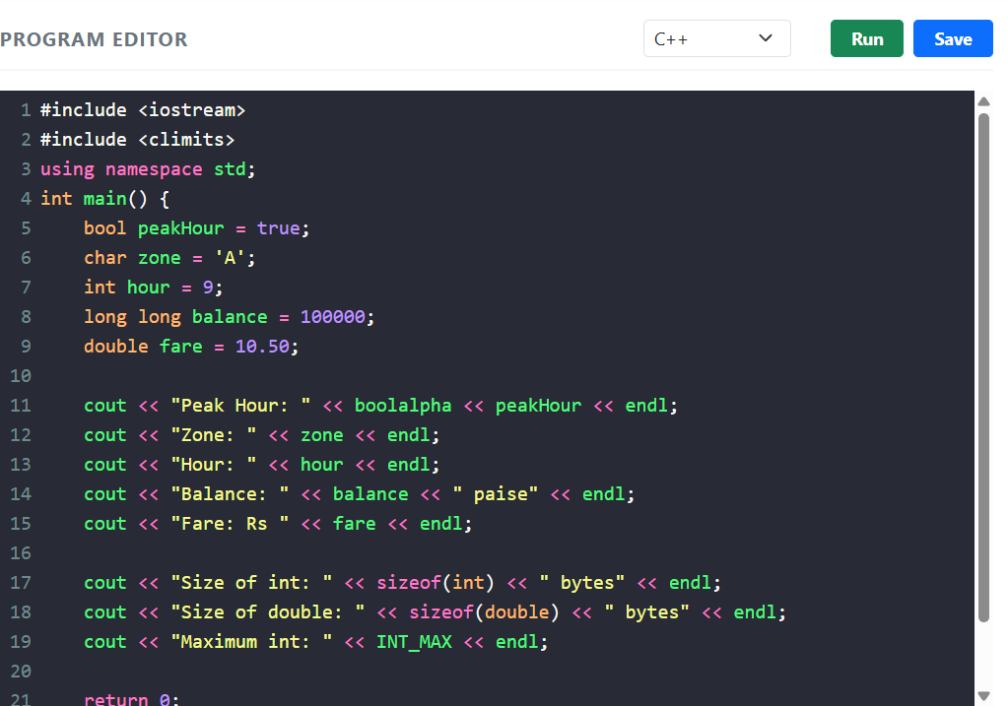
}

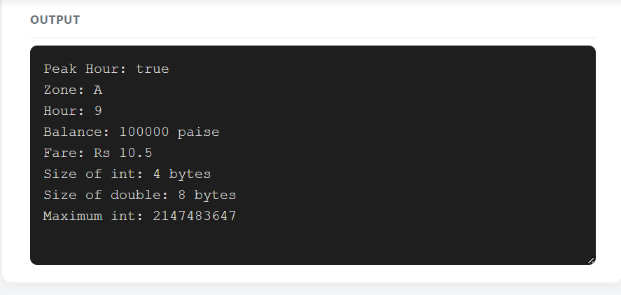

TASK 4 – Control Implicit Conversions 4 Marks Bloom’s Level: K5 – Evaluate

Identify every place in the program where C++ converts a value from one type to another without being told.
Discuss:

- Integer division and integer-to-double conversion

- Comparison of signed and unsigned values, and the compiler warning it produces

- Narrowing conversions, and how brace initialisation (int x{3.7};) prevents them • static_cast and when an explicit cast is needed

Predict the Output

Write the exact output of the program below BEFORE running it. Then compile and run it, and explain every difference between your prediction and the actual output.

Code :

#include <iostream> int main()
{

int a = 7, b = 2; double c = a / b; double d =
static_cast<double>(a) / b; std::cout << c << ' '
<< d << '\n';
char ch = 'A' + 2; std::cout << ch
<< ' ' << ch + 1 << '\n';
bool flag = 5; std::cout << flag << ' ' << std::boolalpha << flag << '\n';
unsigned int u = 1;

int s = -1; std::cout << (s < u ? "s < u" : "s
>= u") << '\n';

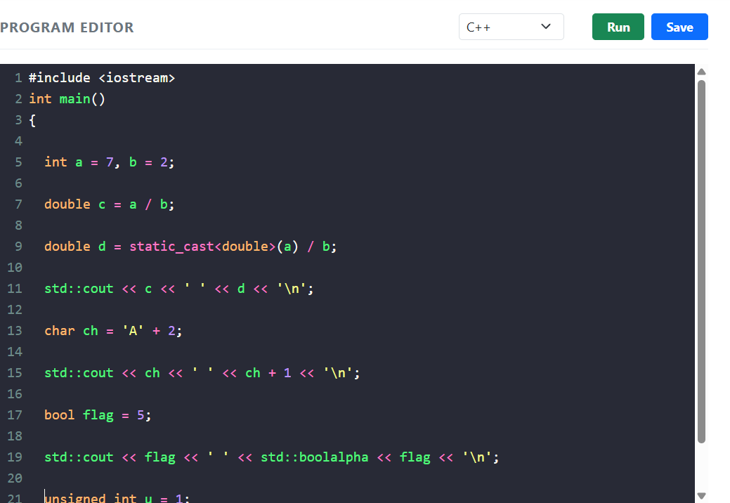

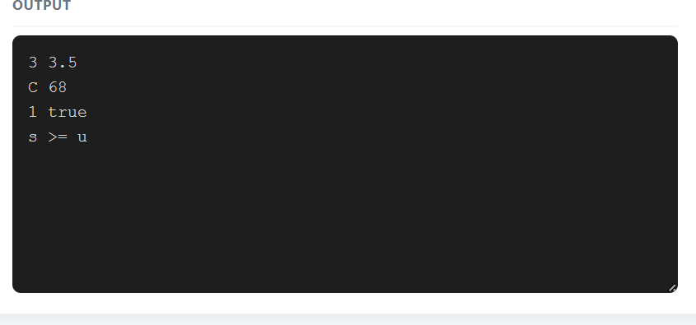
TASK 5 – Write Correct Expressions with the Right Precedence 4 Marks Bloom’s Level: K5 – Evaluate
Write the expressions for the peak check, the surcharge and the concession.

Discuss:

- Operator precedence and associativity in each expression, including the conditional operator
?: and compound assignment

- The difference between x++ and ++x, and why i = i++ is a mistake

- The result of / and % with negative operands

- Why (hour >= 8 && hour < 10) || (hour >= 17 && hour < 20) is correct and hour >= 8 && hour < 10 || hour >= 17 && hour < 20 is equivalent but harder to read

Predict the Output

Write the exact output of the program below BEFORE running it. Then compile and run it, and explain every difference between your prediction and the actual output.

Code:

#include <iostream> using namespace std; int main() {
int x = 5, y = 3;

cout << x + y * 2 << " " << (x + y) * 2 << endl; int z = x++ + ++y;
cout << z << " " << x << " " << y << endl;

cout << (x > y ? x : y) << " " << x % 4 * 2 << endl; cout << 10 / 3 << " "
<< 10 % 3 << " "

<< -10 / 3 << " "

<< -10 % 3 << endl;

int k = 0;

for (int i = 0; i < 10; i += 3) { k += i;

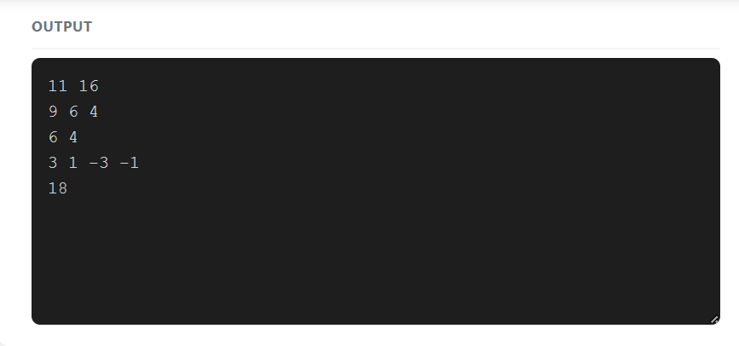
}

cout << k << endl; return 0;
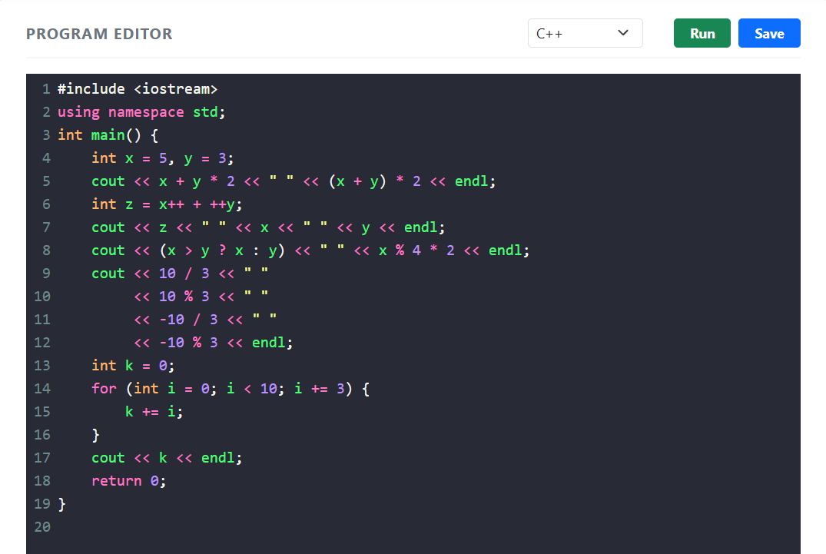
}

TASK 6 – Design the Control Structures 4 Marks Bloom’s Level: K5 – Evaluate
Design the decision and looping logic for computing a fare and processing a day’s journeys. Discuss:
- When to use if–else, a switch on the zone, and the conditional operator

- How a for loop, a range-based for loop and a while loop could process the journeys, and which is best
- Where break and continue are needed (for example, skipping an invalid journey) • What happens when no case of a switch matches

Write pseudocode for the fare computation following the SIMATS Engineering – Standard for Algorithmic Pseudocode before writing C++ code.
Complete the Code

Complete TODO 1 and TODO 2 below using a switch statement and integer paise, and execute the program.

Code :

#include <iomanip> #include <iostream>
enum class Zone { Inner, Middle, Outer };

constexpr int BASE_PAISE[] = {1000, 2000, 3000}; // Rs 10, Rs 20, Rs 30

constexpr int PEAK_SURCHARGE_PERCENT = 20; constexpr long long MIN_BALANCE_PAISE = 5000; // Rs 50 must remain on the card

long long fare(Zone z, bool peak)

{

// TODO 1: Use a switch on z to pick the base fare from BASE_PAISE, then add

// PEAK_SURCHARGE_PERCENT % in peak hours using integer arithmetic only

}

bool canTravel(long long balance, long long f)

{

// TODO 2: Return true only if the balance left after paying the fare is at least

// MIN_BALANCE_PAISE

}

int main()

{

long long balance = 10000; // Rs 100.00 in paise struct Trip { Zone zone; bool peak; };
Trip trips[] = {{Zone::Inner, false}, {Zone::Outer, true}, {Zone::Middle, false}}; for (const Trip& t : trips) { long long f = fare(t.zone, t.peak); if (canTravel(balance, f)) { balance -= f;
std::cout << "Fare Rs " << f / 100 << '.' << std::setw(2)

<< std::setfill('0') << f % 100 << std::setfill(' ');

} else {

std::cout << "Denied (low balance)";

}

std::cout << " balance Rs " << balance / 100 << '\n';

}

}

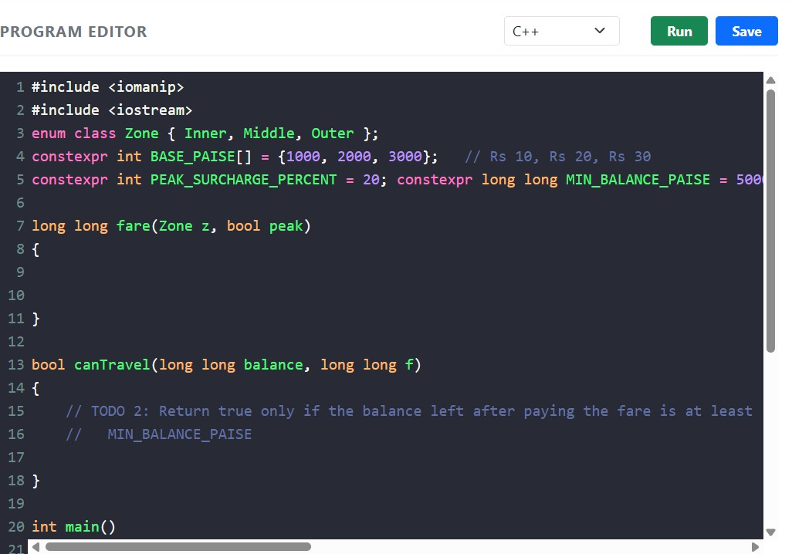

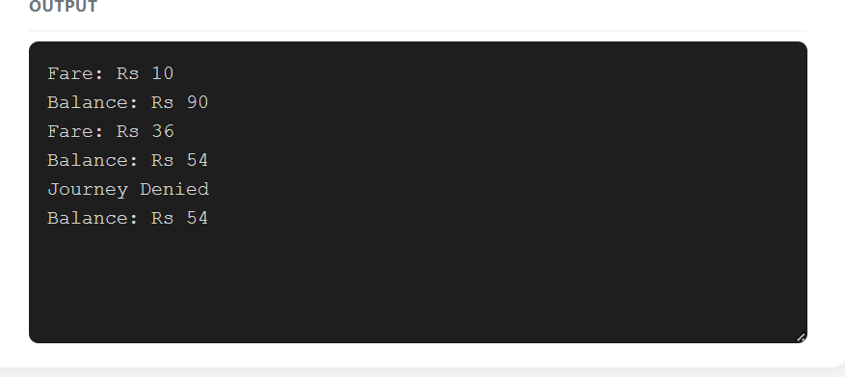

TASK 7 – From Procedural to Object-Oriented 4 Marks

Bloom’s Level: K5 – Evaluate Rewrite the fare logic in two styles. Discuss:

- A procedural version with separate variables and free functions

- An object-oriented version with a SmartCard class that keeps its balance private and offers deduct() and canTravel()
- How the class prevents a negative balance

- Which version is easier to change when the minimum balance changes

Code:

#include <iostream> using namespace std; class SmartCard { private:
long long balance; public:
SmartCard(long long amount) { balance = amount;
}

bool canTravel(long long fare) {

return fare >= 0 && balance - fare >= 5000;

}

bool deduct(long long fare) { if (canTravel(fare)) {
balance -= fare; return true;
}

return false;

}

long long getBalance() {

return balance;

}

};

int main() {

SmartCard card(10000);

if (card.deduct(3000)) {

cout << "Journey Accepted" << endl;

} else {

cout << "Journey Denied" << endl;

}

cout << "Balance: " << card.getBalance() << " paise" << endl;

return 0;

}

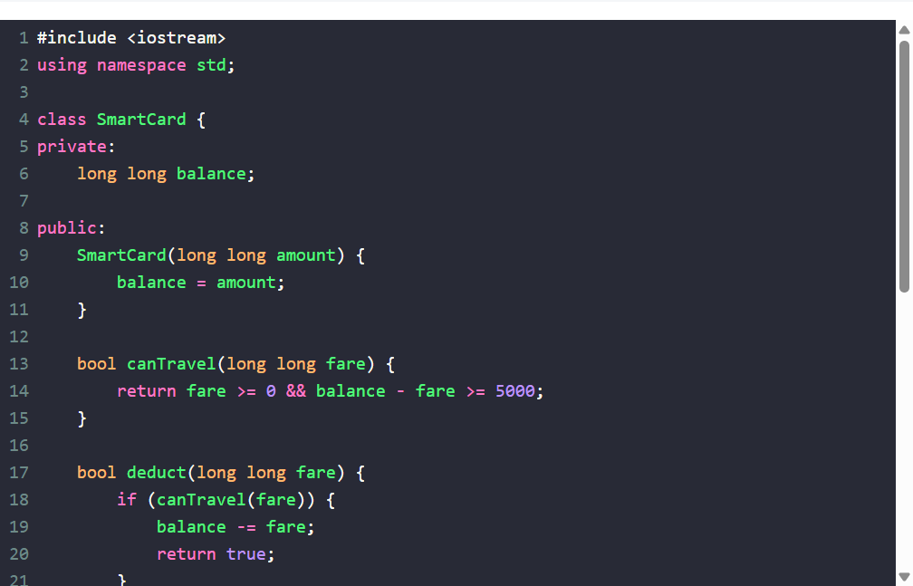

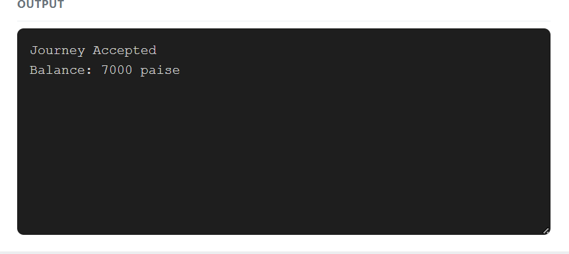
TASK 8 – Read and Print Data Safely 4 Marks Bloom’s Level: K5 – Evaluate
Design the input and output of the gate program. Discuss:

- Reading values with cin and checking cin.fail() when the operator types letters instead of numbers
- Clearing the error state with cin.clear() and discarding the bad input

- Formatting money with <iomanip> (setw, setfill, fixed, setprecision)

- Printing a neat journey report

Code :

#include <iostream> #include <iomanip> #include <limits> using namespace std;

int main() { int hour;

cout << "Enter journey hour: ";

while (!(cin >> hour) || hour < 0 || hour > 23) {

cout << "Invalid input. Enter hour between 0 and 23: ";

cin.clear(); cin.ignore(numeric_limits<streamsize>::max(), '\n');
}

long long fare = 1235;

cout << "Journey Hour: " << hour << endl;

cout << "Fare: Rs "

<< fare / 100 << "."

<< setw(2) << setfill('0') << fare % 100

<< endl;

return 0;

}

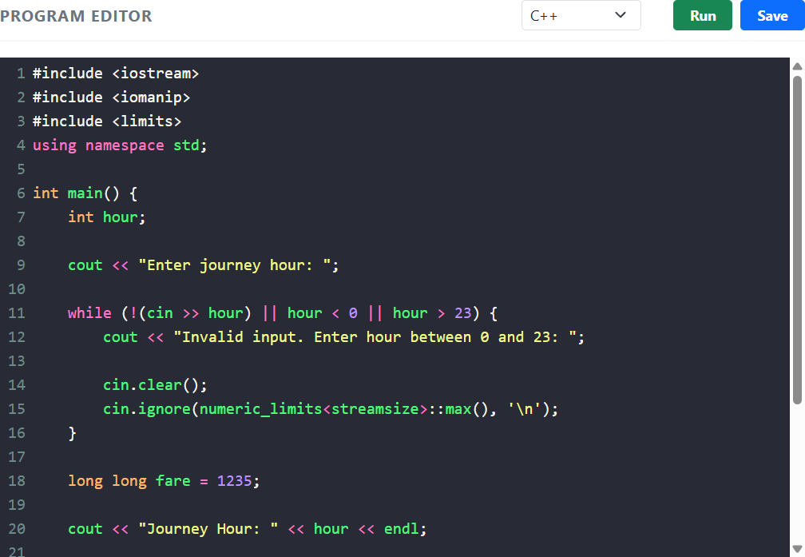

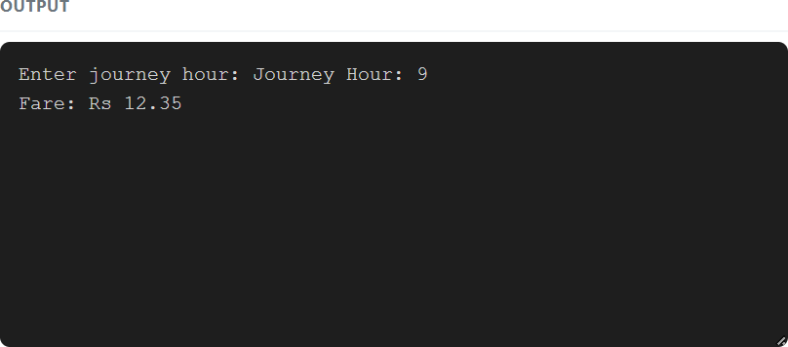

TASK 9 – Implement and Test the Fare Logic 4 Marks Bloom’s Level: K5 – Evaluate
Implement the complete fare logic and test it. Test:
- Normal journeys in each zone, peak and off-peak

- Boundary cases: exactly 8:00, 10:00, 17:00 and 20:00; a balance that leaves exactly Rs 50

- Invalid cases: an unknown zone, a negative recharge, letters typed for the hour • A small set of 5 journeys whose total you calculate by hand

Code:

#include <iostream> using namespace std;

int main() {

int fares[] = {1000, 2000, 3000};

string zones[] = {"Inner", "Middle", "Outer"};

for (int i = 0; i < 3; i++) {
cout << zones[i] << " Off-Peak Fare: Rs "
<< fares[i] / 100.0 << endl;

cout << zones[i] << " Peak Fare: Rs "
<< (fares[i] * 120 / 100) / 100.0
<< endl;
}

int hours[] = {8, 10, 17, 20};

cout << "\nPeak Hour Testing:\n";

for (int hour : hours) {
bool peak = (hour >= 8 && hour < 10) || (hour >= 17 && hour < 20);

cout << hour << ":00 - "
<< (peak ? "Peak" : "Off-Peak")
<< endl;
}

return 0;
}

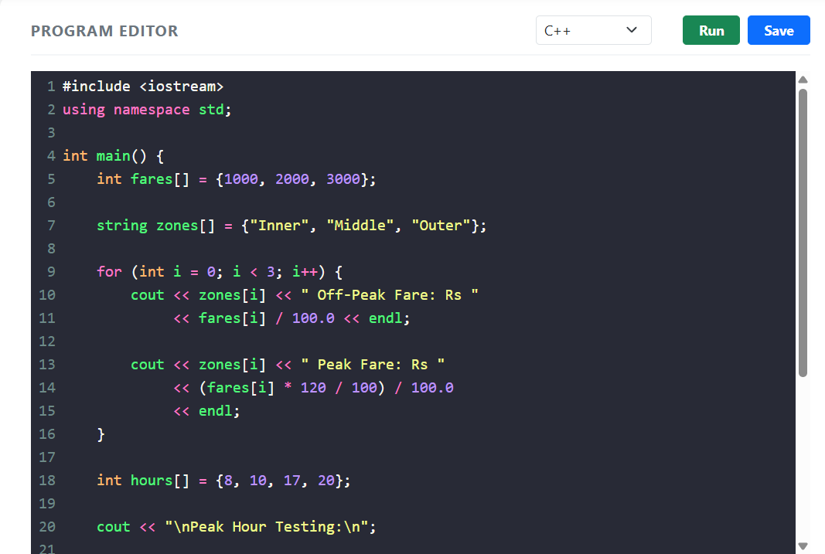

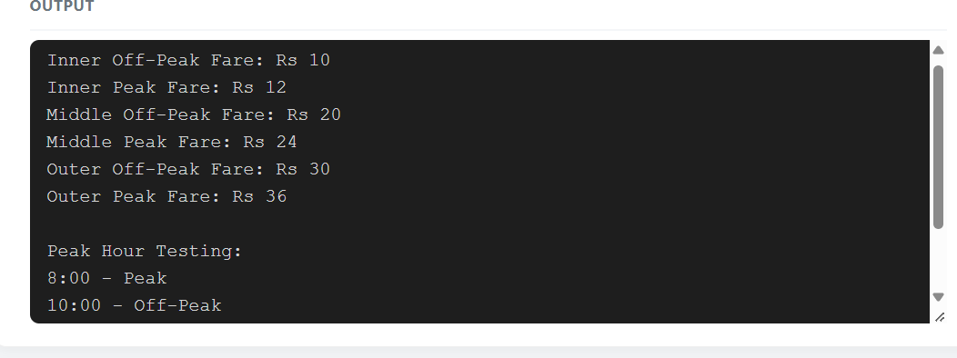
TASK 10 – Compare Expectations with Execution 4 Marks Bloom’s Level: K5 – Evaluate
Compare what you expected with what actually happened. Discuss:

- Whether the double and integer-paise totals for 20,000, 500,000 and 3,000,000 journeys agree, and by how much they differ
- Whether int overflows for the network total

- The compiler warnings you received with -Wall -Wextra and what each meant • Reasons for any difference

Code:

#include <iostream> using namespace std;

int main() {

long long fare = 3600;

long long journeys[] = { 20000,
500000,

3000000

};

for (long long count : journeys) { long long total = count * fare;

cout << "Journeys: " << count << endl; cout << "Total Collection: Rs "
<< total / 100 << endl;

cout << "Total in Paise: "

<< total << endl << endl;

}

return 0;

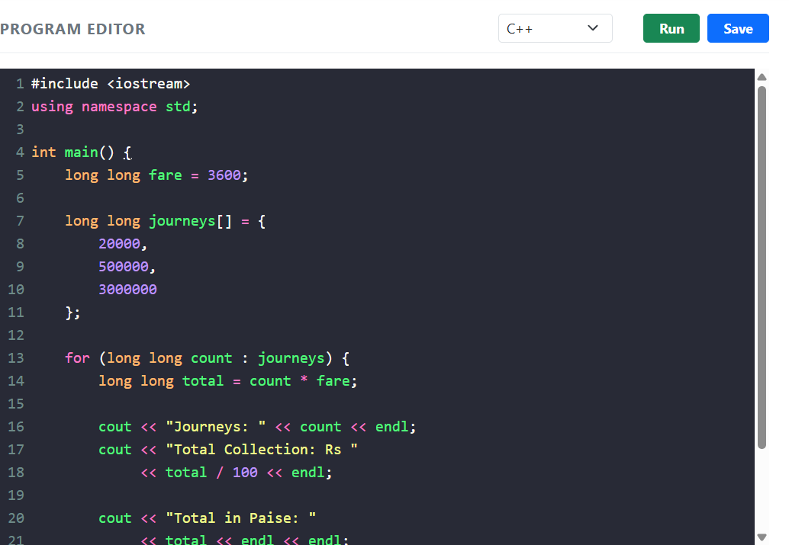
}

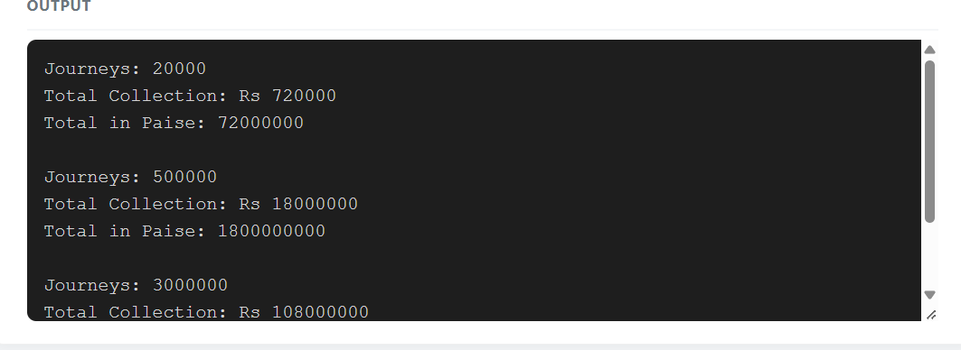

TASK 11 – Recommend and Defend the Final Design 4 Marks Bloom’s Level: K5 – Evaluate

Recommend the final design for the metro. Discuss:
- The types, constants and classes you recommend and why

- How a fare revision will be carried out

- The limitations of your design

- Whether the design remains correct for the whole network

Code:

#include <iostream> #include <array> using namespace std; enum class Zone {
Inner, Middle, Outer
};

constexpr array<long long, 3> FARES = { 1000, 2000, 3000
};

class SmartCard { private:
long long balance; public:
SmartCard(long long amount) { balance = amount;
}

long long calculateFare(Zone zone, bool peak) { int index = static_cast<int>(zone);
if (index < 0 || index >= 3) return -1;
long long fare = FARES[index]; if (peak)
fare += fare * 20 / 100; return fare;
}

void travel(Zone zone, bool peak) {

long long fare = calculateFare(zone, peak);

if (fare < 0) {

cout << "Invalid Zone" << endl;

}

else if (balance - fare >= 5000) { balance -= fare;
cout << "Journey Successful" << endl;

cout << "Fare: Rs " << fare / 100.0 << endl;

}

else {

cout << "Insufficient Balance" << endl;

}

}

void showBalance() {

cout << "Balance: Rs " << balance / 100.0 << endl;

}

};

int main() {

SmartCard card(20000); card.travel(Zone::Inner, false); card.travel(Zone::Middle, true); card.travel(Zone::Outer, false); card.showBalance();
return 0;

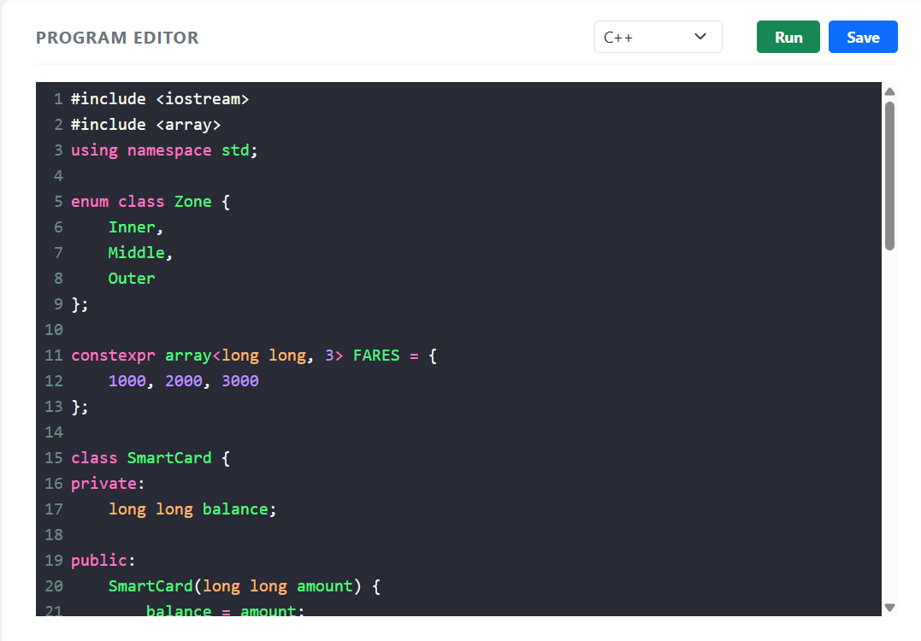
}

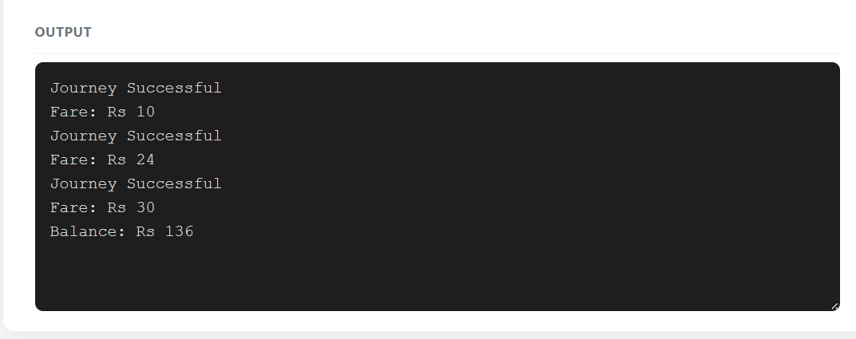

DAY-4 DESIGN CHALLENGE

TASK 12 – Re-evaluate and Adapt the Design 8 Marks Bloom’s Level: K5 – Evaluate
Changed Requirement

The metro adds a fourth zone (Airport, Rs 60), a 10% weekend discount that does not combine with the peak surcharge, and a monthly pass that allows unlimited journeys in two chosen zones.
Re-evaluate your original design. You may RETAIN → MODIFY → or REDESIGN your original solution.
- Impact Analysis – 2 Marks

Identify which constants, enum values, expressions, switch statements and classes are affected. Evidence Expected
A clear analysis of how the changed requirements affect the original design.

- Evaluation of the Original Design – 2 Marks

Evaluate whether the switch-based fare logic and the SmartCard class can absorb the changes, using worked examples.
Evidence Expected

A technically supported evaluation of the original design.

- Adaptation or Redesign – 2 Marks

Describe and implement the revised design (for example: a fare table indexed by zone, a separate discount rule, a Pass class).

Evidence Expected

An appropriate design response with working code.

- Evidence-Based Defence – 2 Marks

Defend your decision using test results and the trade-offs involved. Evidence Expected
A well-supported final decision integrating tests and the changed requirements.

Code:

#include <iostream> #include <array> using namespace std; enum class Zone {
Inner, Middle, Outer, Airport
};

constexpr array<long long, 4> FARES = { 1000, 2000, 3000, 6000
};

class MonthlyPass { private:
bool active;

Zone zone1, zone2; public:
MonthlyPass(bool status, Zone a, Zone b) {

active = status; zone1 = a; zone2 = b;
}

bool covers(Zone zone) {

return active && (zone == zone1 || zone == zone2);

}

};

class SmartCard { private:
long long balance; public:
SmartCard(long long amount) { balance = amount;
}

long long calculateFare(Zone zone, bool peak, bool weekend) { int index = static_cast<int>(zone);
if (index < 0 || index >= 4) return -1;
long long fare = FARES[index]; if (weekend) {
fare -= fare * 10 / 100;

}

else if (peak) {

fare += fare * 20 / 100;

}

return fare;

}

void travel(Zone zone, bool peak, bool weekend, MonthlyPass& pass) {

if (pass.covers(zone)) {

cout << "Monthly Pass Accepted" << endl; return;
}

long long fare = calculateFare(zone, peak, weekend);

if (fare < 0) {

cout << "Invalid Zone" << endl;

}

else if (balance - fare >= 5000) { balance -= fare;

cout << "Journey Accepted" << endl;

cout << "Fare: Rs " << fare / 100.0 << endl;

}

else {

cout << "Journey Denied: Low Balance" << endl;

}

}

void showBalance() {

cout << "Remaining Balance: Rs "

<< balance / 100.0 << endl;

}

};

int main() {

SmartCard card(20000);

MonthlyPass pass(true, Zone::Inner, Zone::Middle);

card.travel(Zone::Inner, true, false, pass);

card.travel(Zone::Airport, true, true, pass);

card.travel(Zone::Outer, true, false, pass);

card.showBalance();

return 0;

}

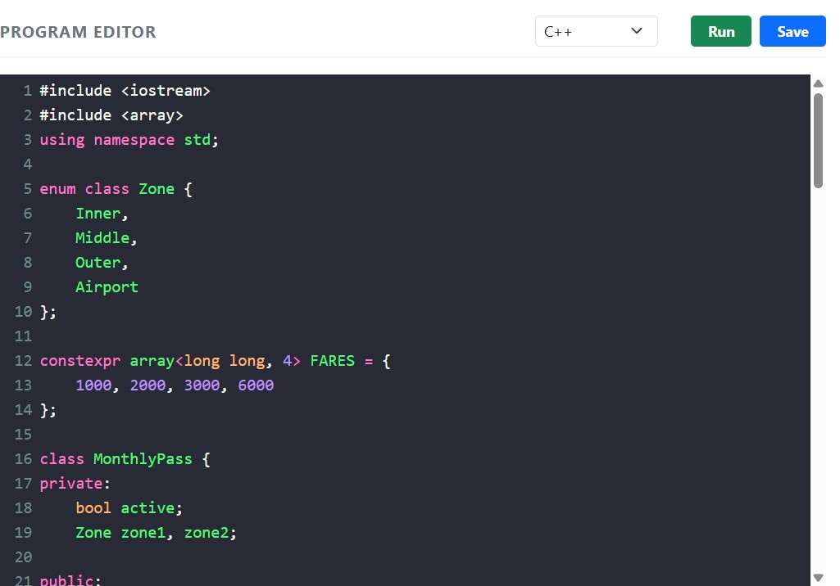

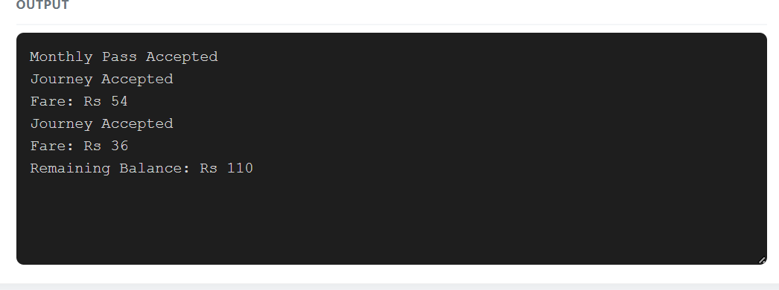
MARK DISTRIBUTION

Task Bloom’s Level Marks

Task 1 – Object-Oriented Analysis K5 – Evaluate 4 Task 2 – Tokens and Constants K5 – Evaluate 3
Task 3 – Data Types and Compatibility K5 – Evaluate 4 Task 4 – Implicit Conversions K5 – Evaluate 4

Task 5 – Operators and Precedence K5 – Evaluate 4 Task 6 – Control Structures K5 – Evaluate 4
Task 7 – Procedural vs Object-Oriented K5 – Evaluate 4

Task 8 – Input and Output K5 – Evaluate 4

Task 9 – Implementation & Testing | K5 – Evaluate | 4
Task 10 – Expectation vs Execution | K5 – Evaluate | 4
Task 11 – Final Recommendation | K5 – Evaluate | 4
Subtotal 42
Task 12 – Day-4 Design Challenge | K5 – Evaluate | 8
TOTAL 50

Submission Requirements

- GitHub repository link (mandatory) containing the executed code for every task, including every completed “Complete the Code” program, with input files, output screenshots and a README.md.
- Your assignment report containing the required evidence for Tasks 1–12, including UML diagrams, pseudocode, test tables and complexity analyses.

Assessment Verification

Students may be asked to explain, execute or modify any part of their code during a brief verification discussion/viva. The student should be able to explain and defend the work submitted as their own.

